ISSUE#1 7436
- Register Job Seeker join now
- Shortlist
- Drop down is blank and should be “Select an option”
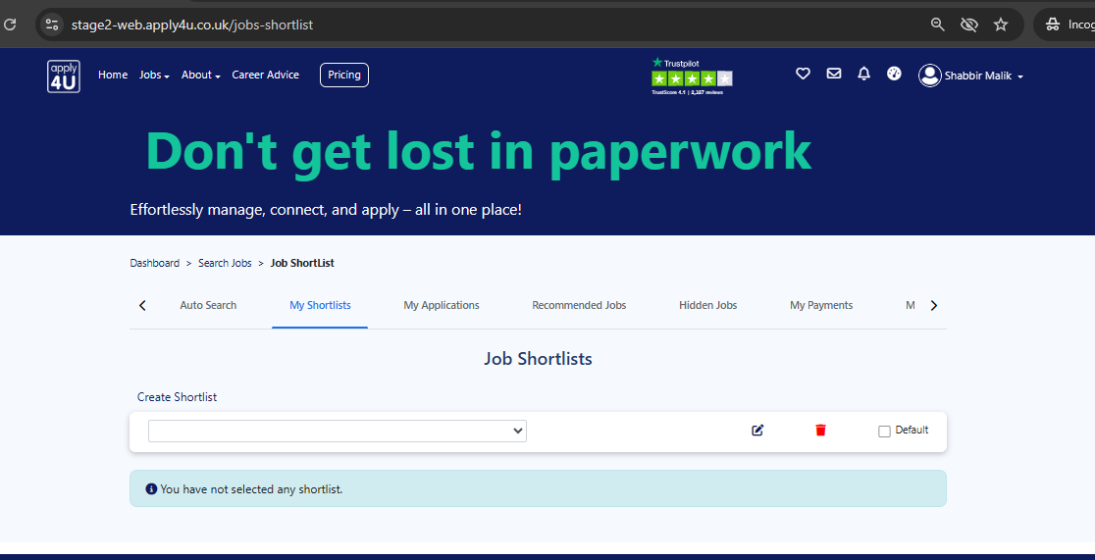

ISSUE#1 7437
- When trying to submit a reference via email seeing something went wrong error without Signed in
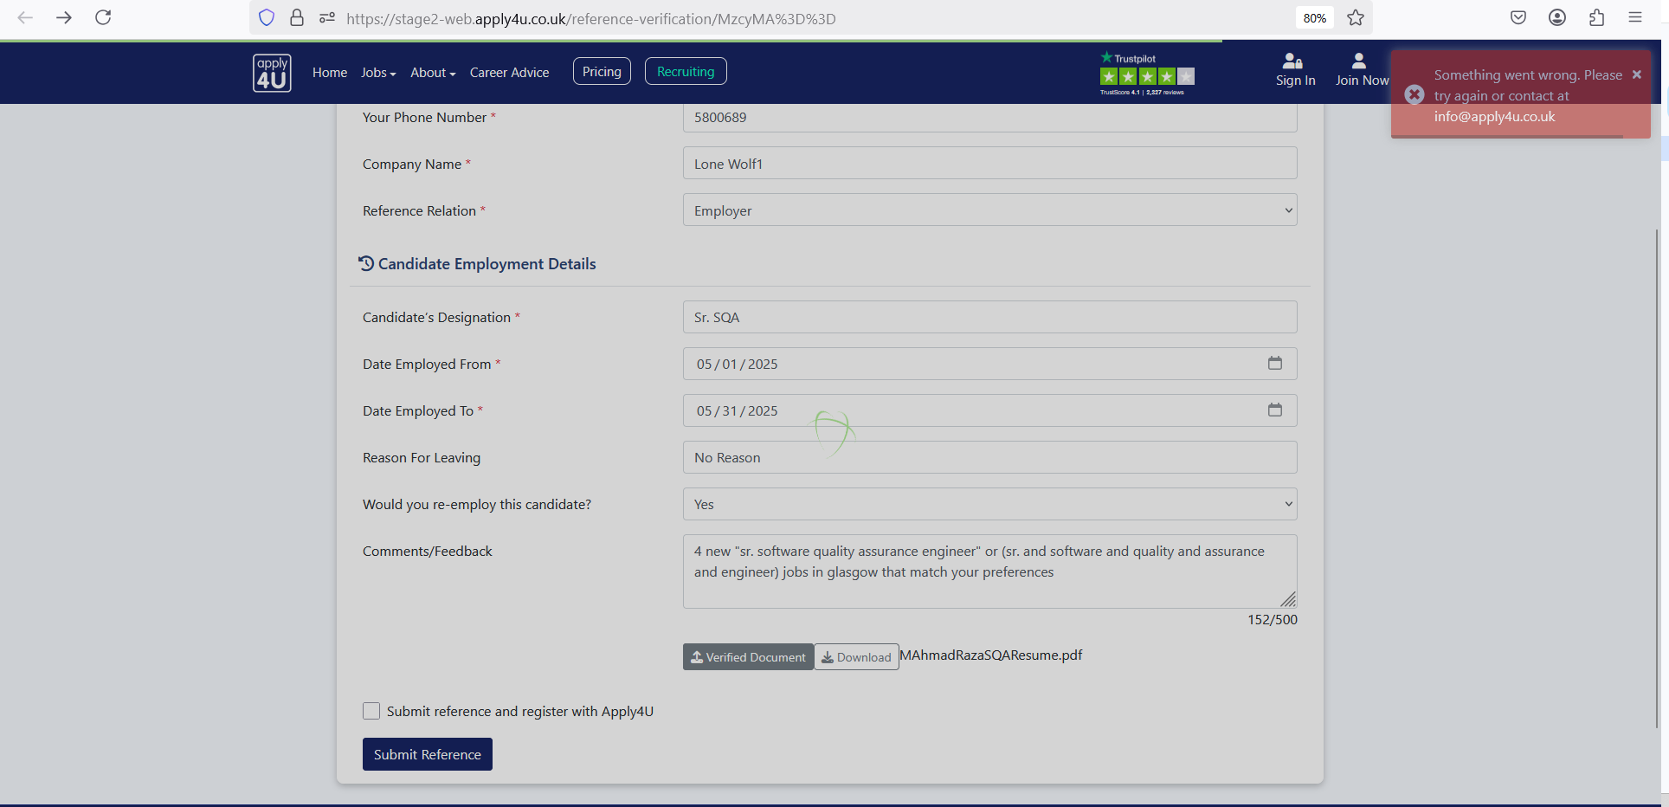
ISSUE #3: 7438
Account Settings - Email Address - Not able to Add new
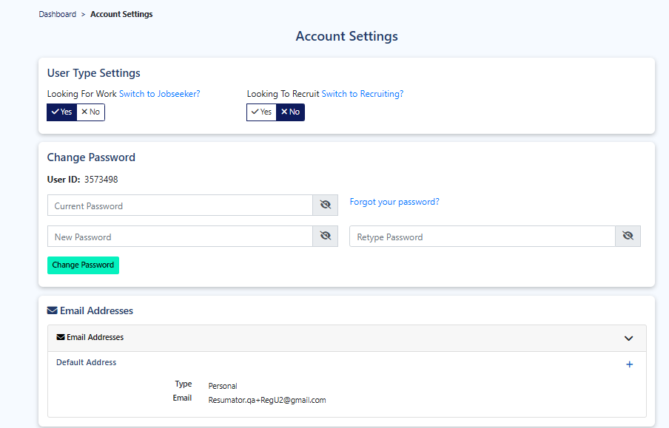
ISSUE #4: 7439
TotalJob Email Alerts - Not able to delete default email alerts

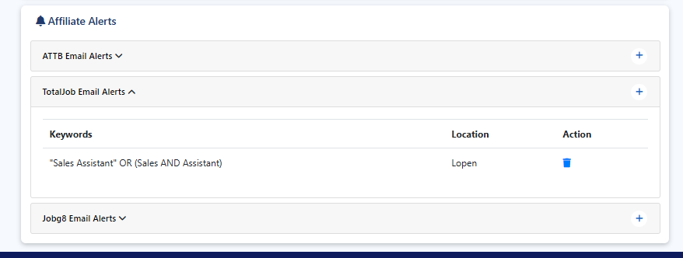

ISSUE#5: 7440
When you Edit a List on Jobseeker List name does not appear

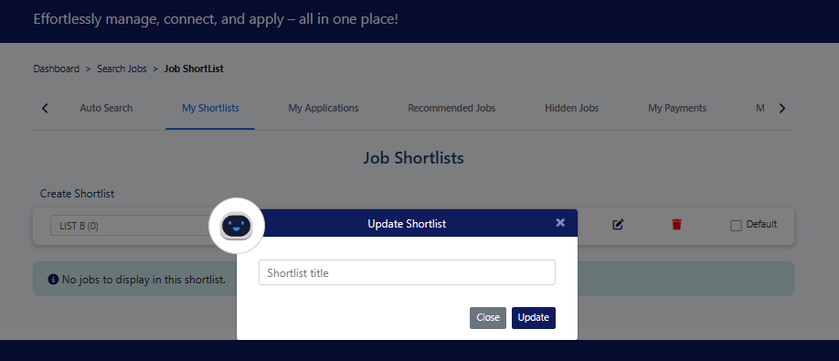

ISSUE #6:

- When we have two shortlists – Job Search results screen – Click on heart icon – Shorlist pop up display and closed, On 2nd attempt its worked fine
ISSUE #7

- Job Details screen taking time to load
ISSUE #8

Auto Search - Job Status Does not display on casrd
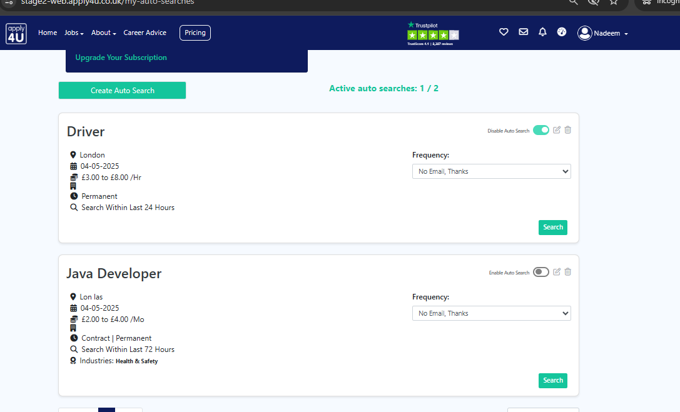

ISSUE Recruiter
- Register with recruiter account without job title then on Thank you screen clicked on Post yu first job – Something went wrong error displayed

