Boolean job Search

Entered the following data in the fields and press “create search”.

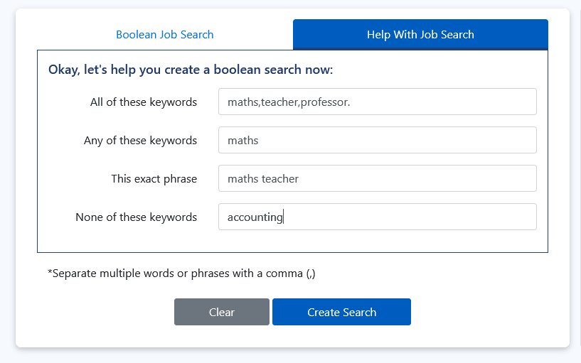

This will enter data into the Boolean search fields.
Created this search for Mathematics Teacher.


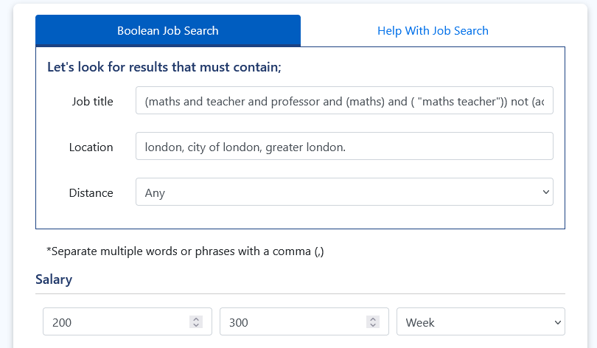

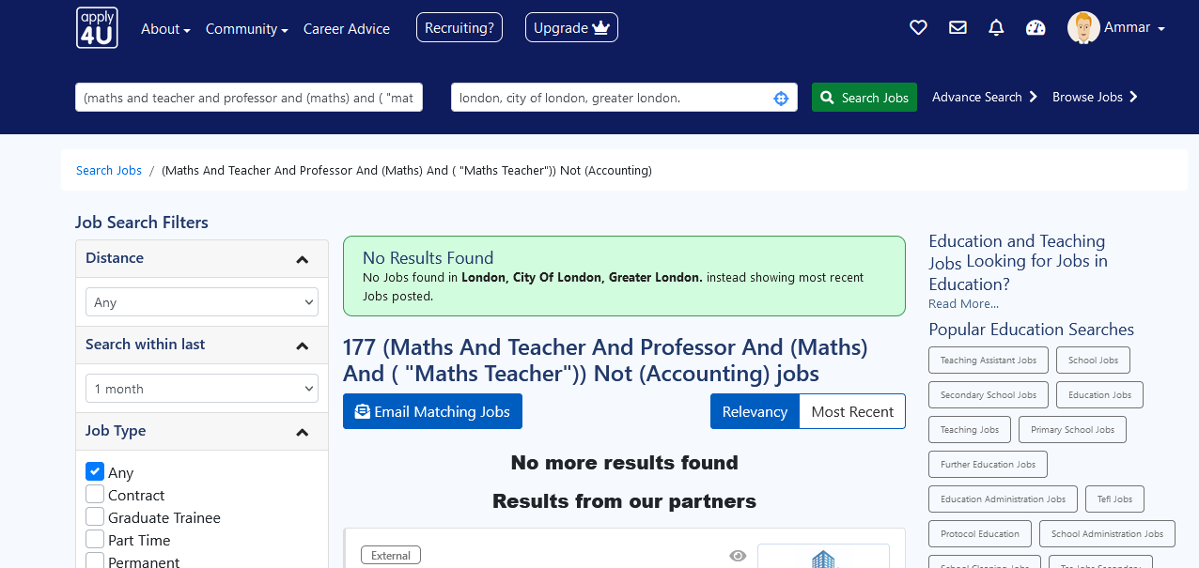
Result:

Search no 2:
Entered data and press “create search”
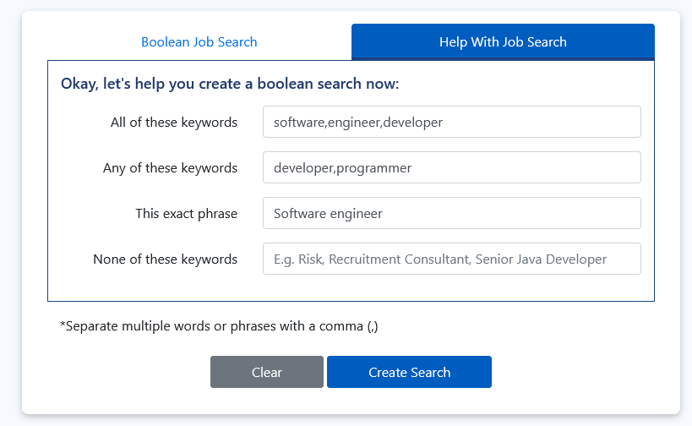

This will enter data into the Boolean search fields.
Saved search for Software Engineer.
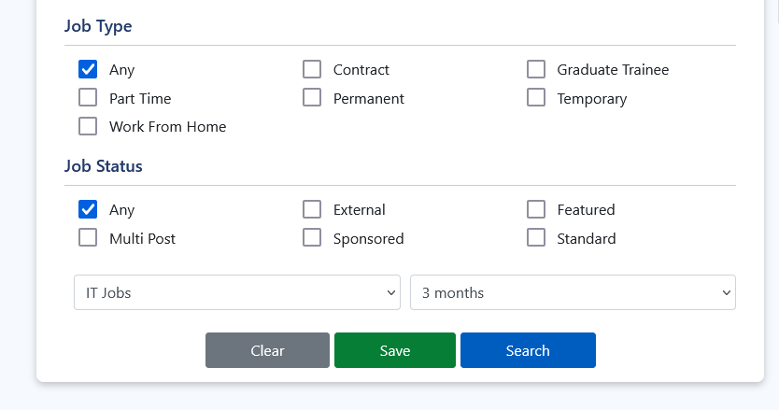
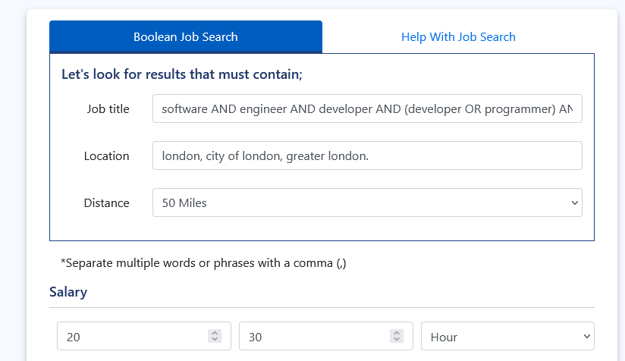

Created this search for “software engineer”.
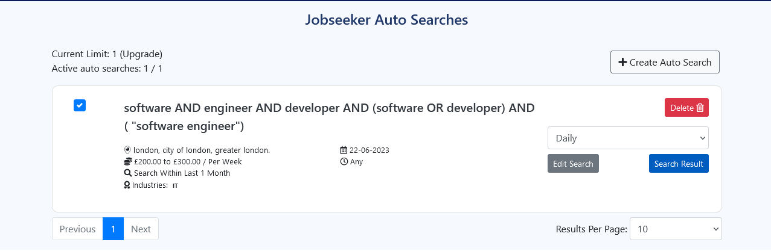

Results:
Highlighted text are the keyword in the search.

