Login Use cases
- Use case 1:
User is able to login with valid credentials.

Inputs:
Go to apply4u.co.uk
Click on sign in and entered following credentials
Email: testreg1230@gmail.com
Pass: Testreg1230

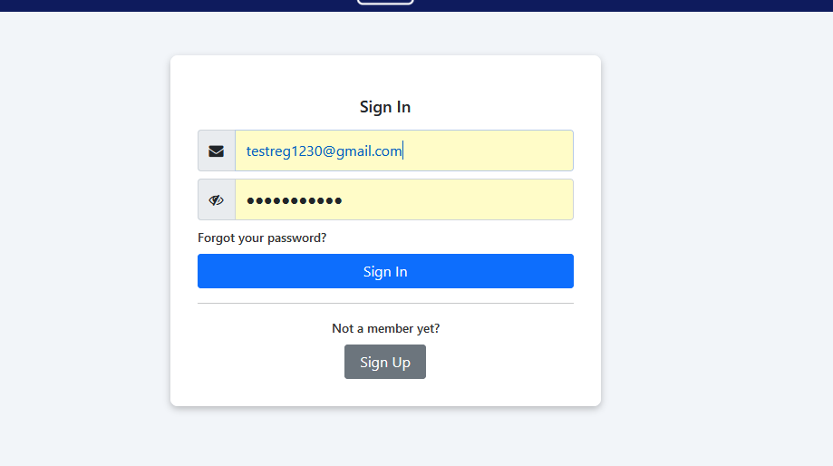

Expectation:
Sign in successfully.
Result:
Signed in Successfully

- Use case 2:
User not able to login with invalid email and valid password
Inputs:
Go to apply4u.co.uk
Click on sign in entered following details in the form
Email: tesreg1230gmail.com
Pass: Testreg1230.
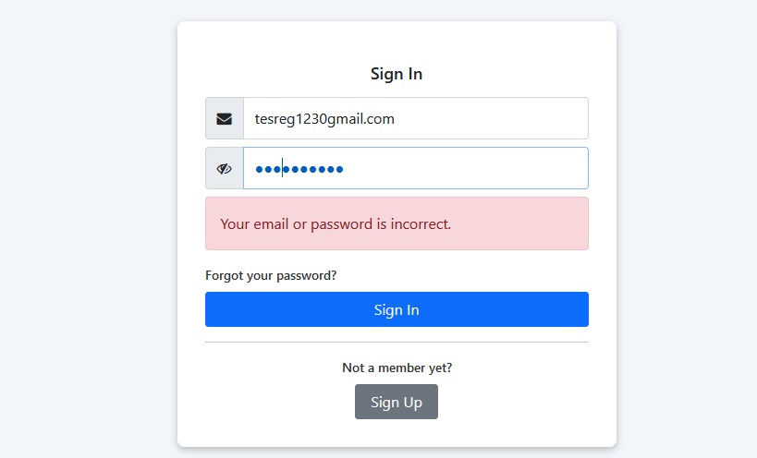
Expectation:
Error message should appear “your password is incorrect”.
Result:
Error message appeared.

Use case 3:
User is not able to sign with valid email and invalid password
Inputs:
Go to apply4u.co.uk
Click on sign in entered following details
Email: testreg1230@gmail.com
Pass: TeStReg1230
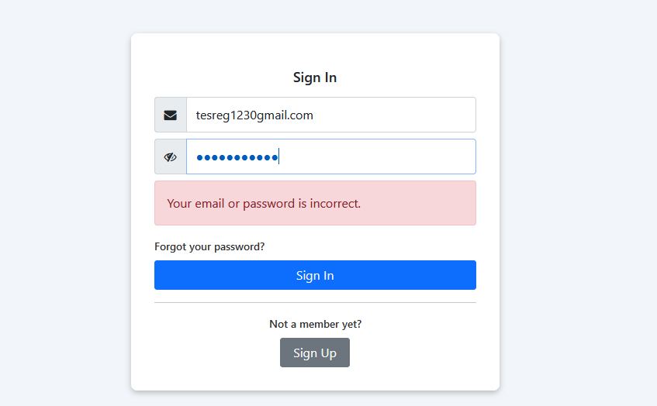
Expectation:
Error message should appear “your password is incorrect”.
Result:
Error message appeared.

Use case 4:
User is not able to sign in with blank spaces
Inputs:
Go to apply4u.co.uk
Click on sign in leave textboxes empty and click sign in button.
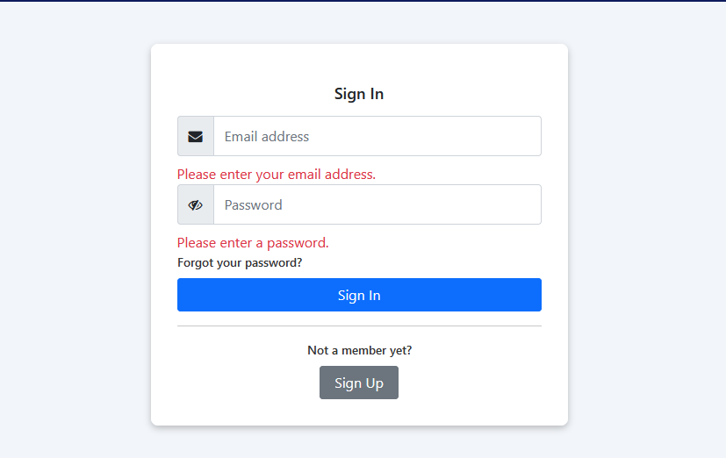
Expectation:
Validation message should appear
Result:
Validation message appeared.

Use case 5:
User is redirected to appropriate page after successful login
Inputs:
Go to https://www.apply4u.co.uk/jobs-applied-for
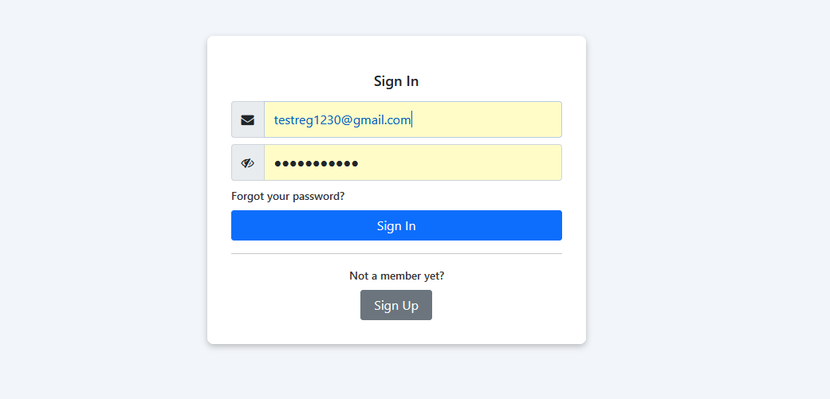
After signing in
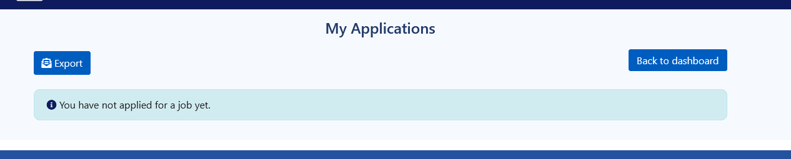
Expectation:
The link entered by user should redirect to sign in page after entering the credentials the website should get redirected to the appropriate page
Result:
Website is redirecting as expected.

Use case 6:
Forgot password should send the password reset link to the given email
Inputs:
Go to apply4u.co.uk
Click on sign in then click on forgot and enter the email.
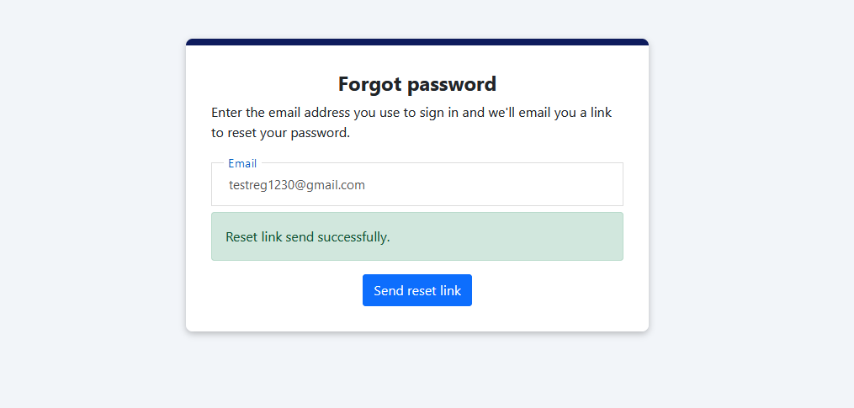
Link received on email
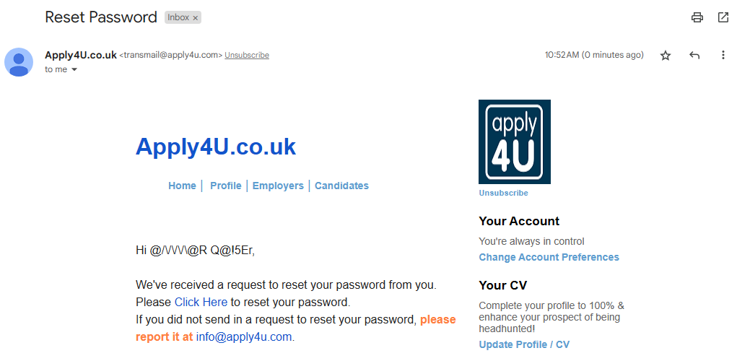

Expectation:
User click on the “forgot password” and enter email in the textbox an email should be received to reset the password
Result:
Reset link is received as expected.
Use case 7:
User is able to view the entered password.
Inputs:
Go to apply4u.co.uk
Click on sign in enter the email and password
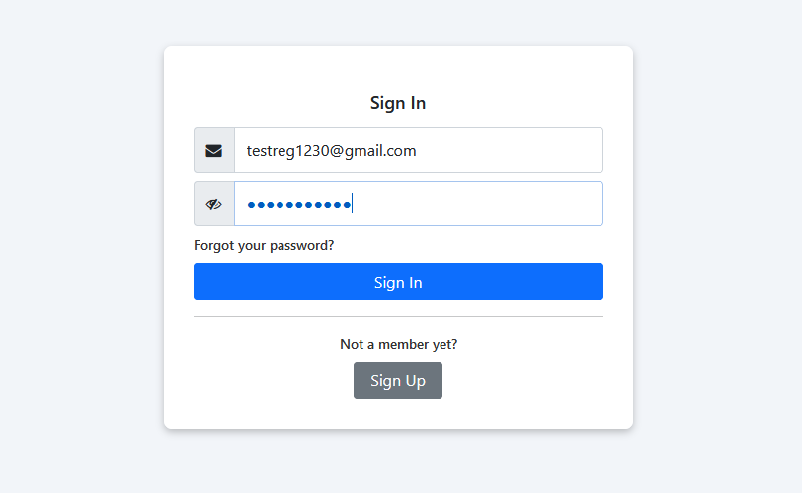
Expectation:
After entering password view password icon must show in the textbox or in the surroundings
Result:
View Password icon is not showing as expected.

Use case 8:
User should get redirect to the registration page.
Inputs
Go to apply4u.co.uk
Click on sign in page then click on the signup button.

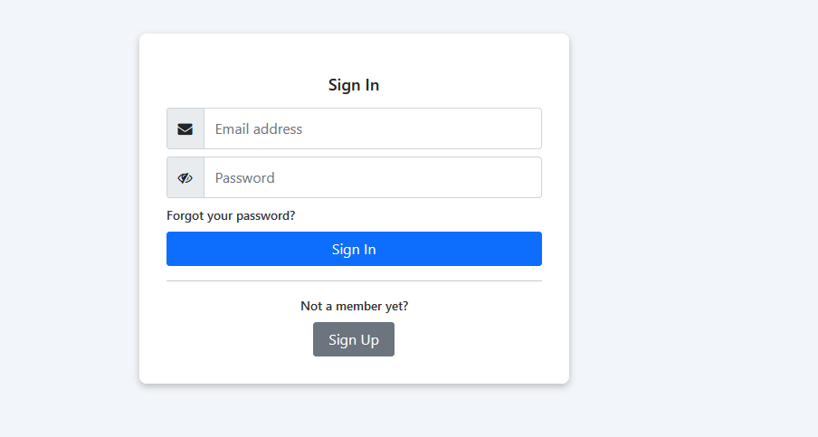
Expectation
the sign up button should redirect to the registration page
Result:
The button is redirecting as expected.

